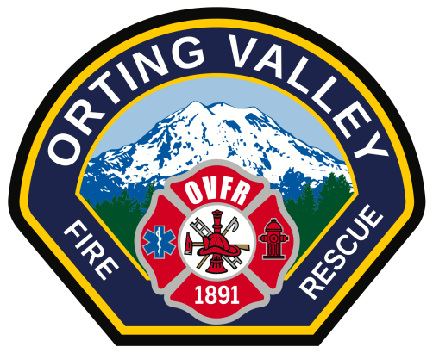

Orting Valley Fire and Rescue is soliciting committee members for the establishment of
For and Against Committees for the renewal of the Maintenance and Operations Levy which will be placed on the ballot of the upcoming election on August 1, 2017.

RCW 29A.32.280 Arguments advocating approval or disapproval-Preparation by committees.
For each measure from a unit of local government that is included in a local voters’ pamphlet, the legislative authority of that jurisdiction shall, not later than forty-five days before the publication of the pamphlet, formally appoint a committee to prepare arguments advocating voters’ approval of the measure and shall formally appoint a committee to prepare arguments advocating voters’ rejection of the measure. The authority shall appoint persons known to favor the measure to serve on the committee advocating approval and shall, whenever possible, appoint persons known to oppose the measure to serve on the committee advocating rejection. Each committee shall have not more than three members; however, a committee may seek the advice of any person or persons. If the legislative authority of a unit of local government fails to make such appointments by the prescribed deadline, the county auditor shall whenever possible make the appointments.

Interested persons should contact Orting Valley Fire and Rescue either in person Monday- Thursday 8:00a.m.-5:00 p.m. or by telephone 360-893-2221 no later than close of business on May 2, 2016 so that committee appointments can be established.

